**Integrated Capstone Project**

**Azure – Batch G2**

# **E R Diagram:**

## Relational Model:

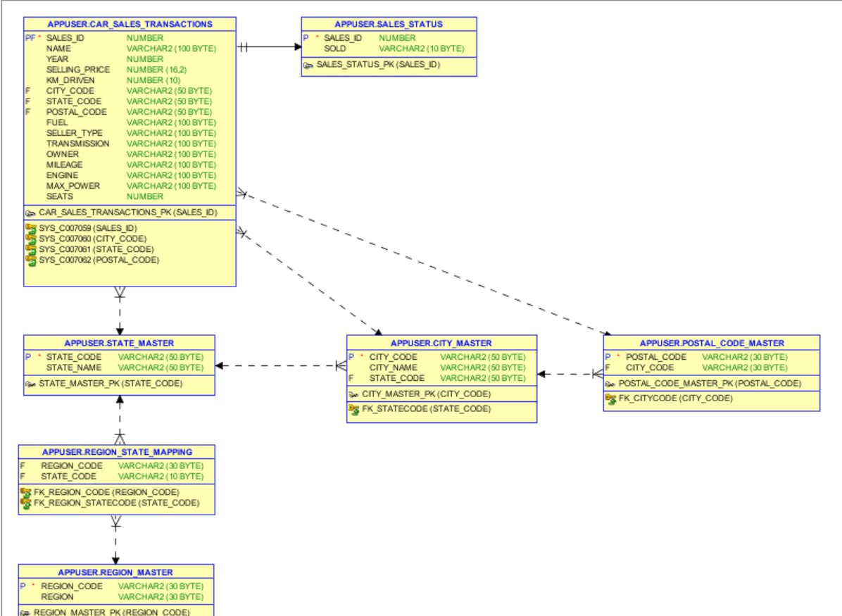

## Logical Model:

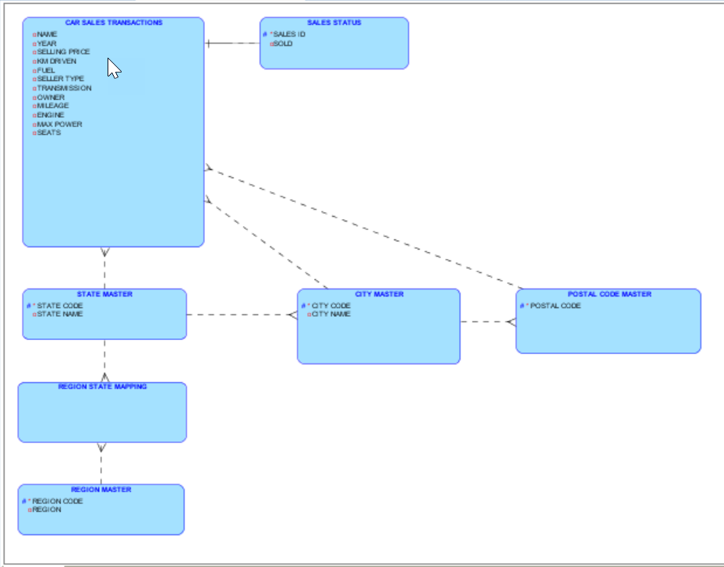

# Queries

# **Query 1** - Generate Info of the cars which is of the type first owner and the year of car purchase is between 2016-2020 and the number of kms driven is less than 80,000

# **Solution** –

# select * from car_sales_transactions where owner='First Owner' and year between 2016 and 2020 and km_driven<80000 order by year;

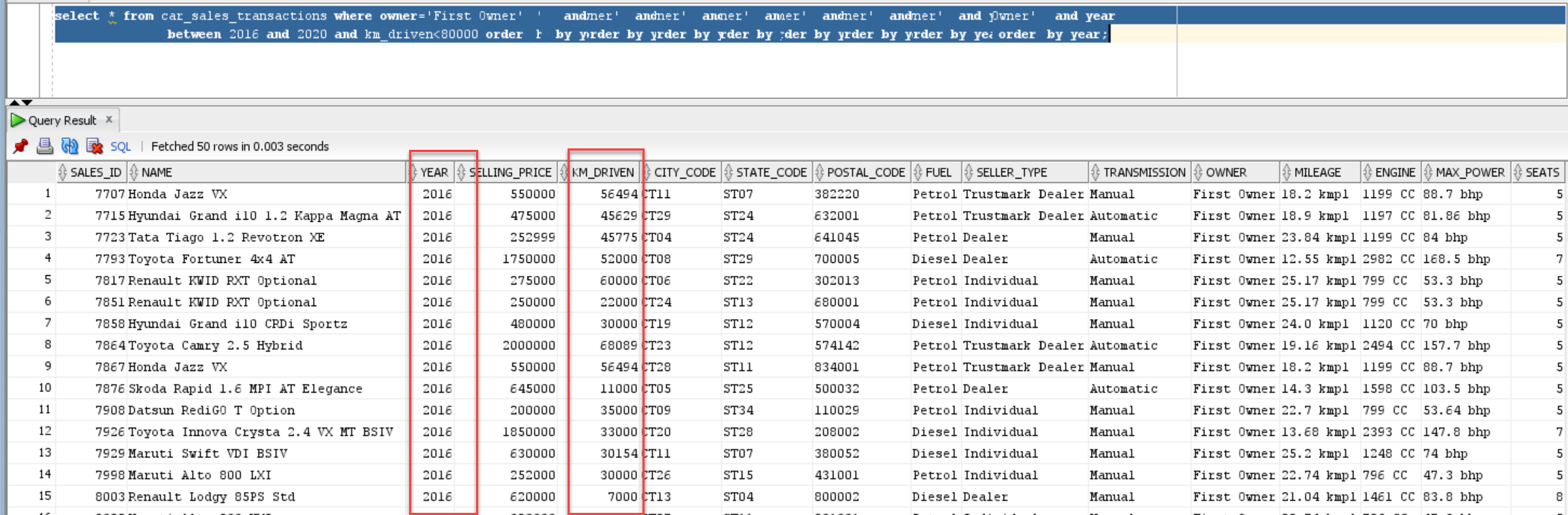

**Query 2** - Generate Info of all the cars whose average mileage is around 25 kmpl and year of car purchase is between 2018-2020 which has minimum seating of 4-5 and fuel type is diesel.(Considering around with boundaries 24 to 26)

**Solution:**

with data as

(

select sales_id,ceil(avg(substr(mileage,0,instr(trim(mileage),' ')))) as avg_mileage

from car_sales_transactions

group by sales_id having avg(substr(mileage,0,instr(trim(mileage),' ')))>24

and avg(substr(mileage,0,instr(trim(mileage),' ')))<26

order by 1

)

select a.* from car_sales_transactions a inner join data d

on a.sales_id=d.sales_id

where a.year between 2018 and 2020 and a.seats>=4 order by year;

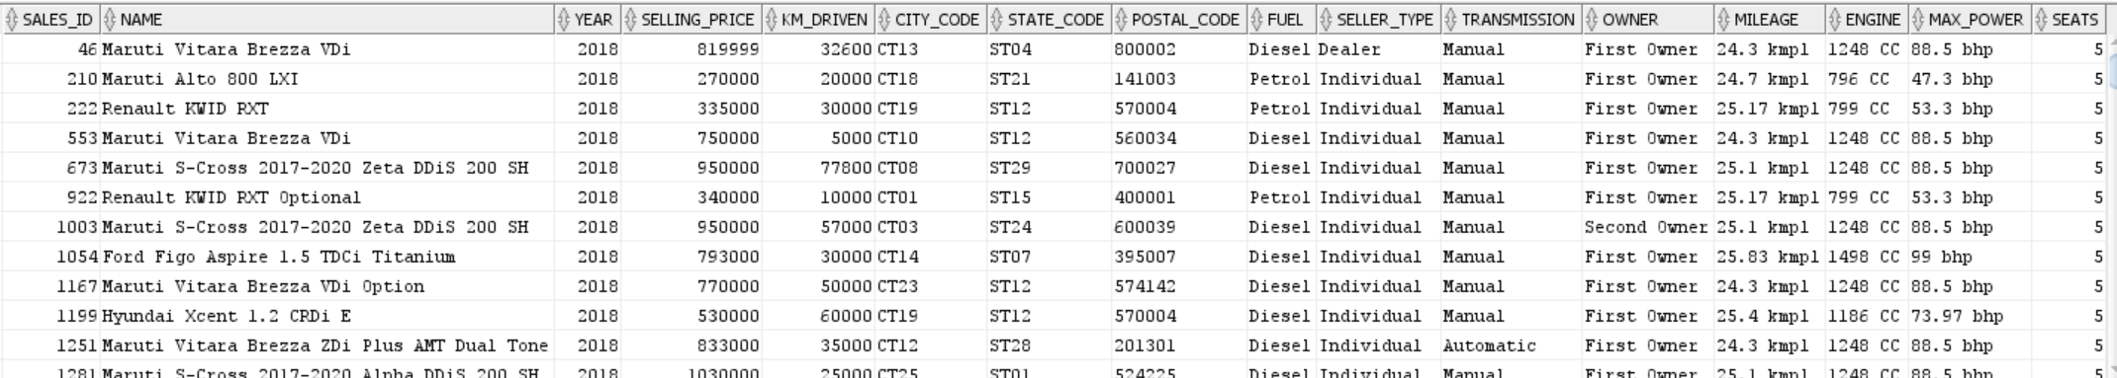

**Query 3 –** Generate Info of all the cars which are not sold, and seller-type is individual or dealer and also which has been used for less than 60000 kms and year of car purchase is 2014-2020.

**Solution:**

select * from car_sales_transactions a inner join sales_status b on

a.sales_id=b.sales_id

where b.sold='N'

and a.seller_type in ('Individual','Dealer') and a.km_driven<60000 and a.year

between 2014 and 2020

order by a.year;

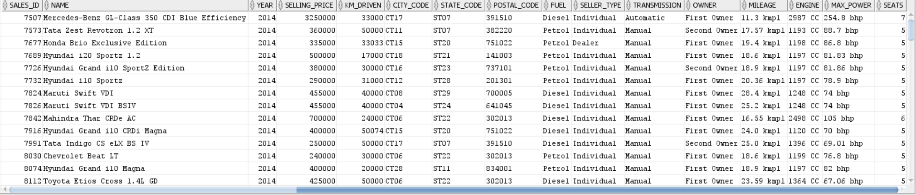

**Query – 4** Generate Info of all the cars which are manual and automatic whose mileage ranges between 20-25kmpl approximately and also which is within these cities(Washington, New York City,Chicago,Los Angeles)

select * from car_sales_transactions where substr(mileage,0,instr(trim(mileage,' ')) between 20 and 25 and city_code in (select city_code from city_master where city_name in ('Mumbai','Delhi','Mysore','Mangalore')); 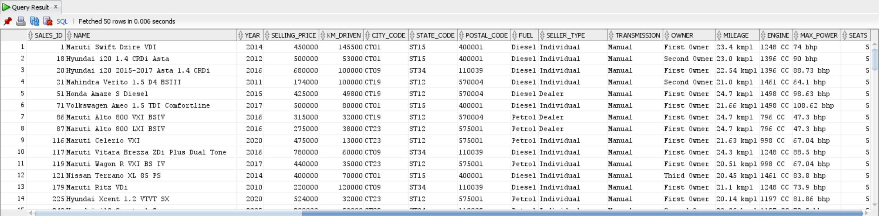

**Query – 5** Generate Info of all the cars which belong to honda category could be either first owner and second owner and also fuel type is petrol and average mileage should be 25kmpl and which are not sold and seating arrangement should be minimum 4

# **Solution:**

# with data as (

# select sales_id,avg(to_number(substr(mileage,0,instr(trim(mileage),' ')))) as avg_mileage

# from car_sales_transactions

# group by sales_id having avg(substr(mileage,0,instr(trim(mileage),' ')))=25 order by 1

# )

# select * from car_sales_transactions a inner join data d on a.sales_id=d.sales_id where a.name like 'Honda%' and a.owner in ('First Owner','Second Owner') and a.fuel='Petrol' and a.seats>=4

# and b.sold='N';

# No rows selected as per given criteria